#### Staff

##### Staff login

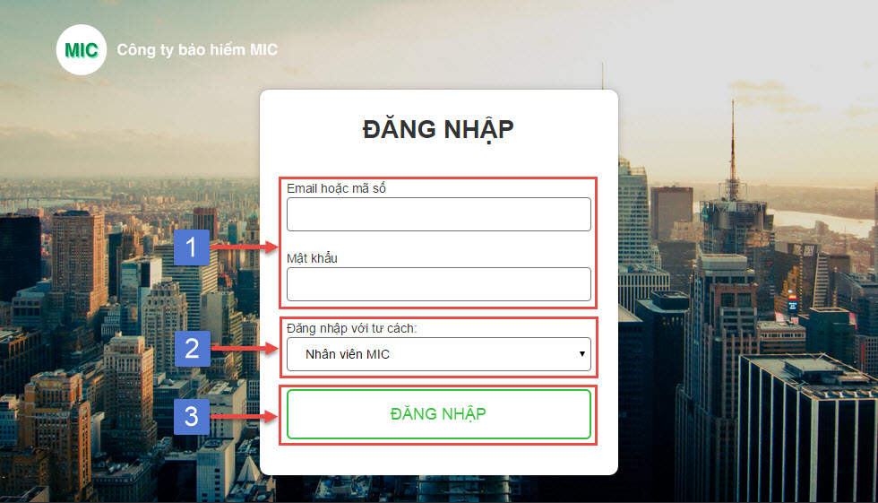

|  |  |
| --- | --- |
| Step | Description |
| 1 | Input email or code and password to login |
| 2 | Select role is “Nhân viên MIC” |
| 3 | Click “ĐĂNG NHẬP” button |

##### Staff manage contract

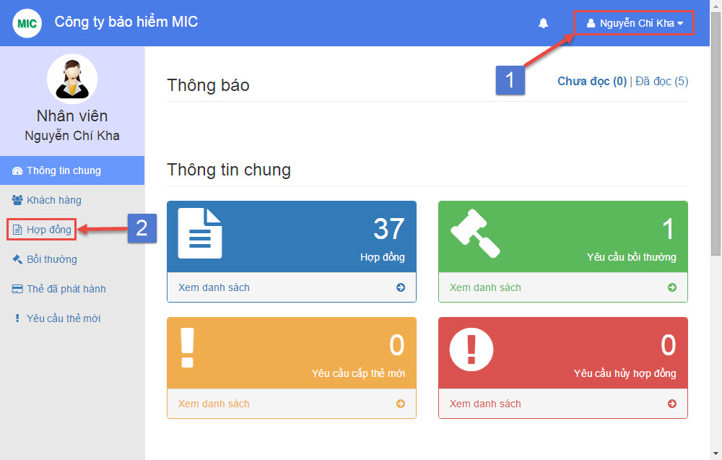

|  |  |
| --- | --- |
| Step | Description |
| 1 | Login with “Staff” role |
| 2 | Select menu “Hợp đồng” from navigation bar |

##### Staff create new contract

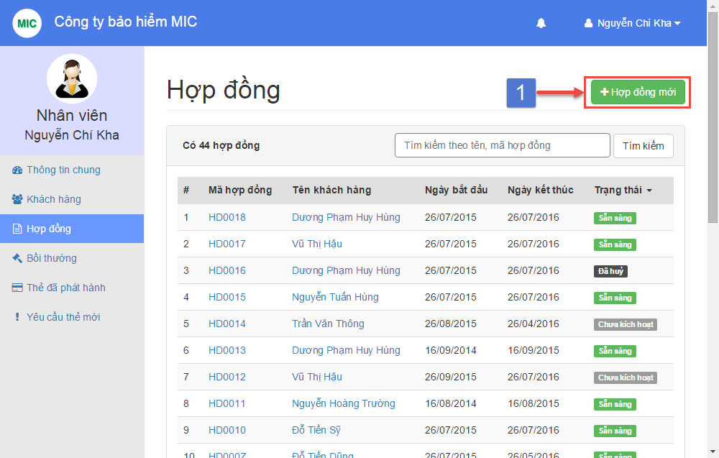

|  |  |
| --- | --- |
| Step | Description |
| 1 | Click on button “Hợp đồng mới” |

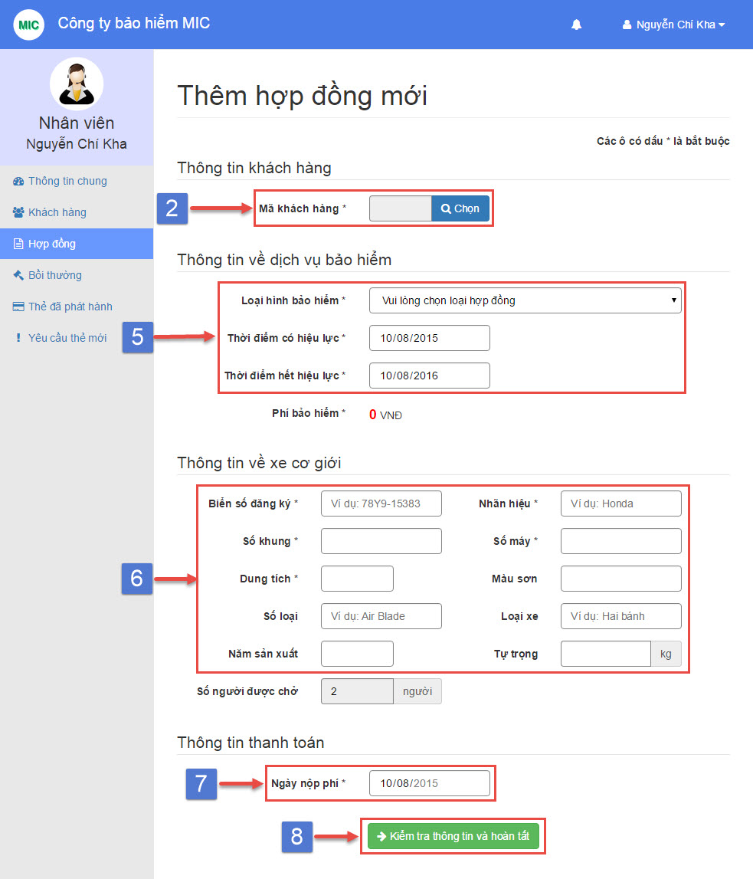

|  |  |
| --- | --- |
| Step | Description |
| 2 | Click “Chọn” button |

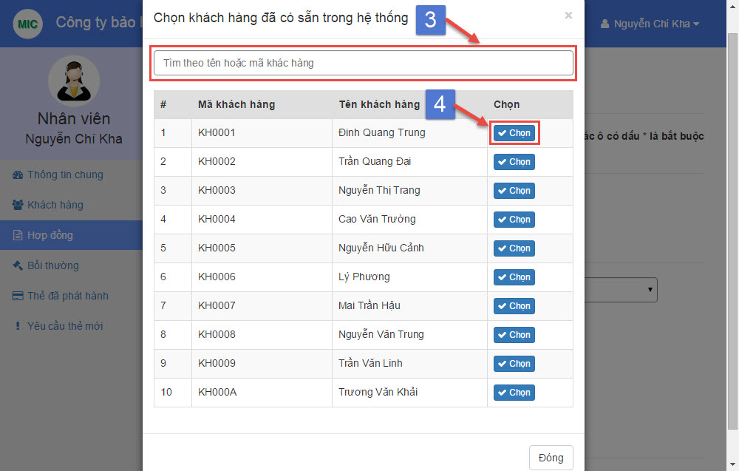

|  |  |
| --- | --- |
| Step | Description |
| 3 | Search customer by name or code |
| 4 | Click “Chọn” button |



|  |  |
| --- | --- |
| Step | Description |
| 5 | Select contract type in “Loại hình bảo hiểm” dropdown list (required)  Choose “Thời điểm có hiệu lực” the start date of this contract (required)  Choose “Thời điểm hết hiệu lực” the end date of this contract (required) |
| 6 | Fill vechile plate, brand, engine, chassis, capacity (required)  Fill color, model code, vehicle type, year of manufacture, weight (optional) |
| 7 | Choose “Ngày nộp phí” the paid date of this contract (required) |
| 8 | Click “Kiểm tra thông tin và hoàn tất” button |

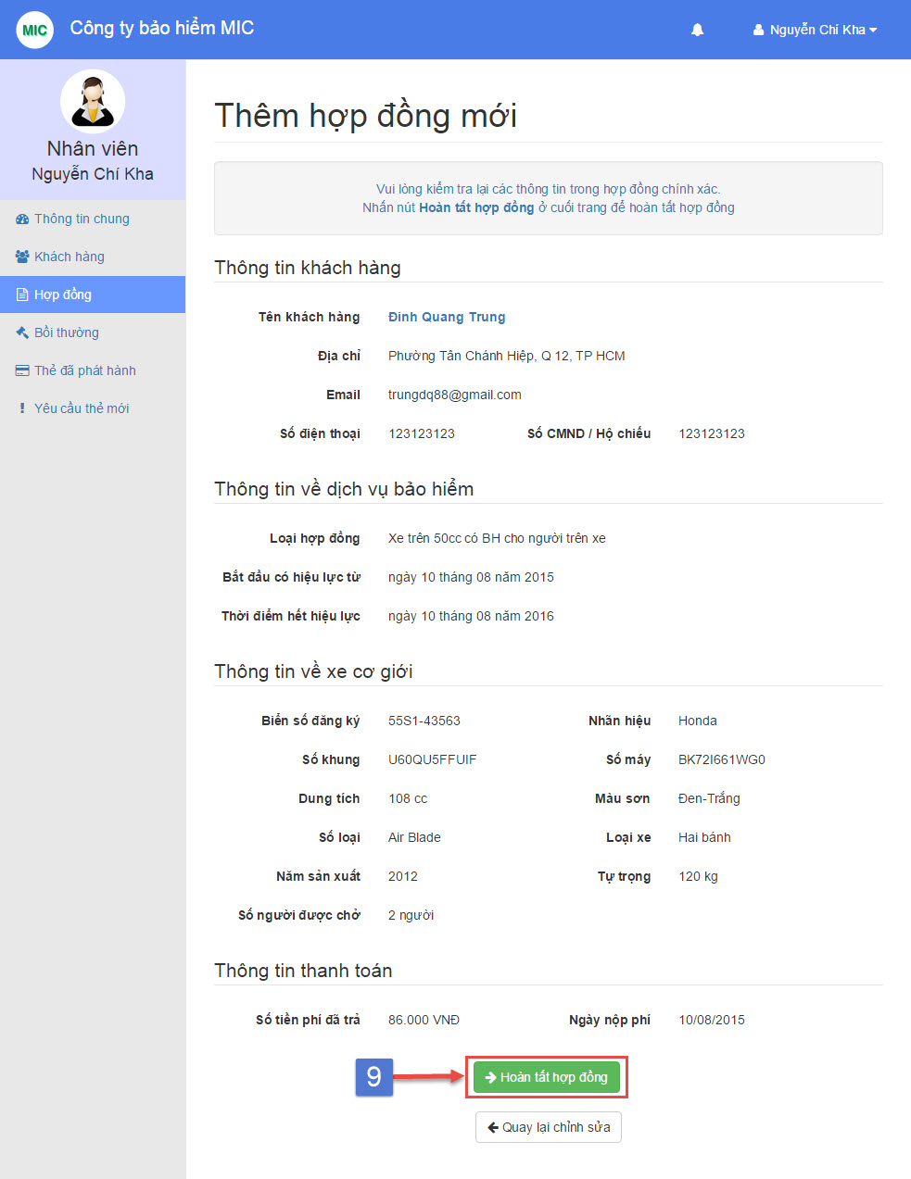

|  |  |
| --- | --- |
| Step | Description |
| 9 | Click “Hoàn tất hợp đồng” button |

##### Staff view contract detail

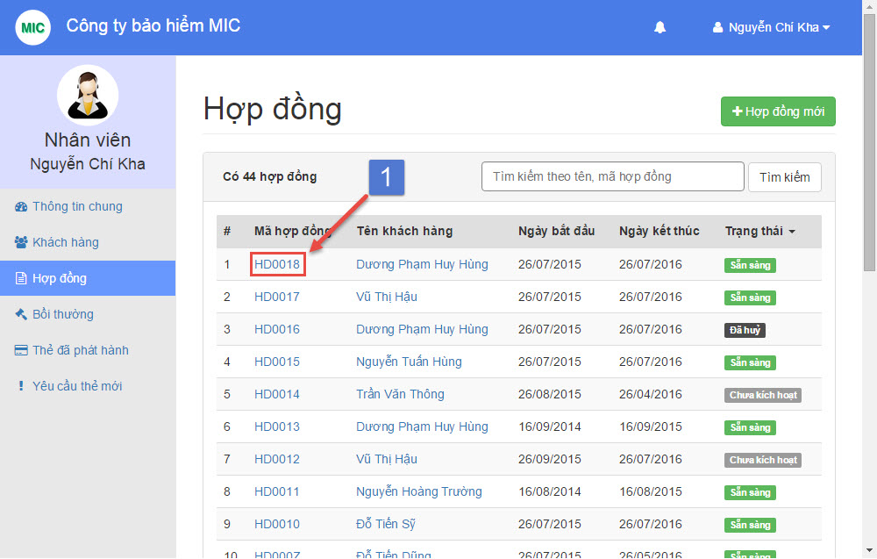

|  |  |
| --- | --- |
| Step | Description |
| 1 | Click on view contract detail link |

##### Staff complete payment

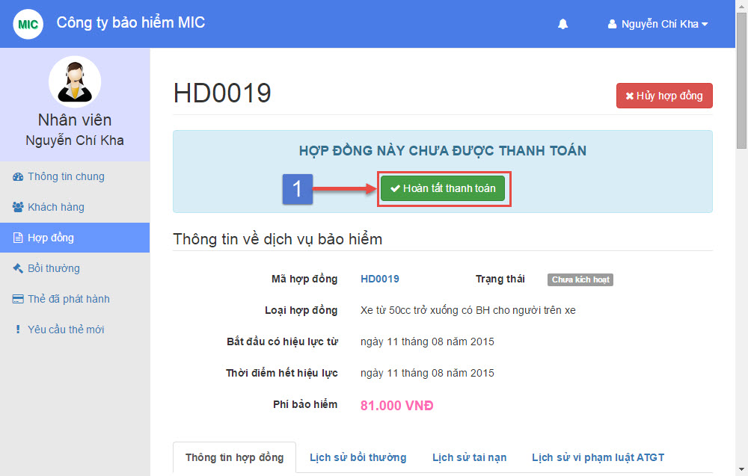

|  |  |
| --- | --- |
| Step | Description |
| 1 | Click “Hoàn tất thanh toán” button |

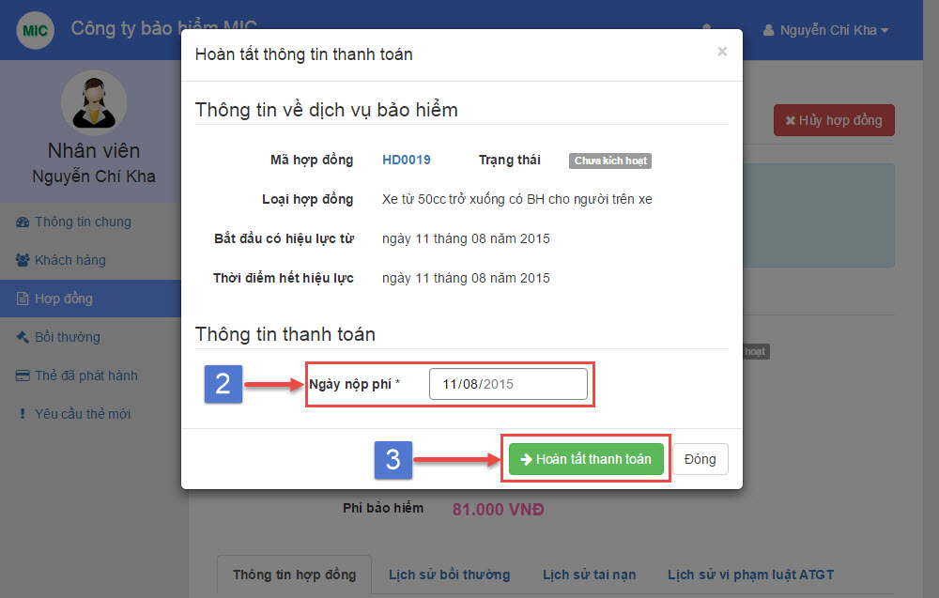

|  |  |
| --- | --- |
| Step | Description |
| 2 | Choose “Ngày nộp phí” the payment paid date (required) |
| 3 | Click “Hoàn tất thanh toán” button |

##### Staff renew contract

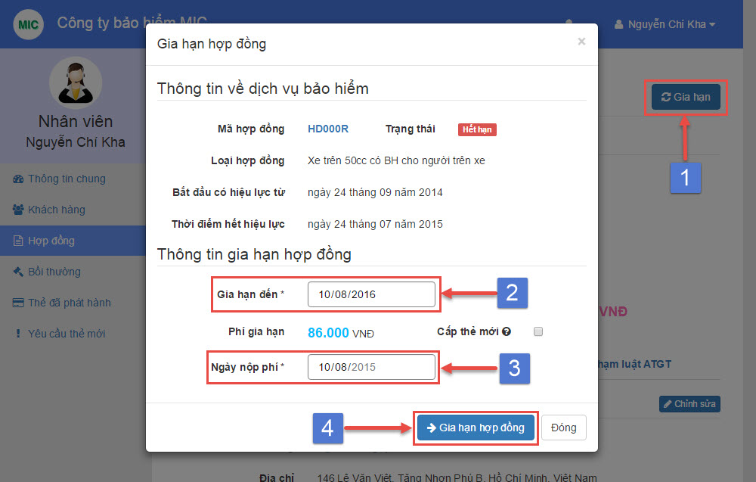

|  |  |
| --- | --- |
| Step | Description |
| 1 | Click “Gia hạn” button |
| 2 | Choose “Gia hạn đến” the contract new expired date (required) |
| 3 | Choose “Ngày nộp phí” the contract paid date (required) |
| 4 | Click “Gia hạn hợp đồng” button |

##### Staff resolve cancel request

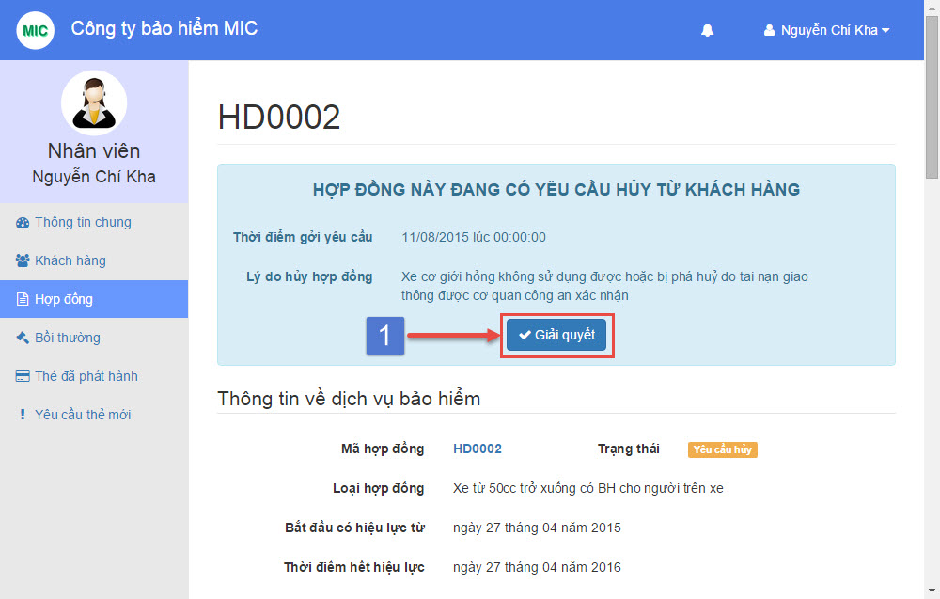

|  |  |
| --- | --- |
| Step | Description |
| 1 | Click “Giải quyết” button |

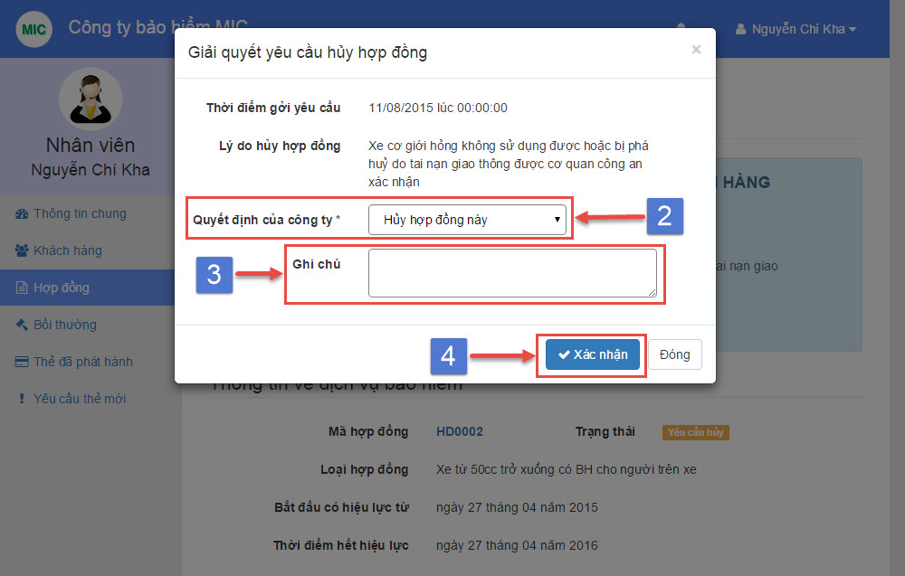

|  |  |
| --- | --- |
| Step | Description |
| 2 | Choose “Quyết định của công ty” (required) |
| 3 | Input “Ghi chú” if company decision is cancel this contract (optional) |
| 4 | Click “Xác nhận” button |

##### Staff cancel contract

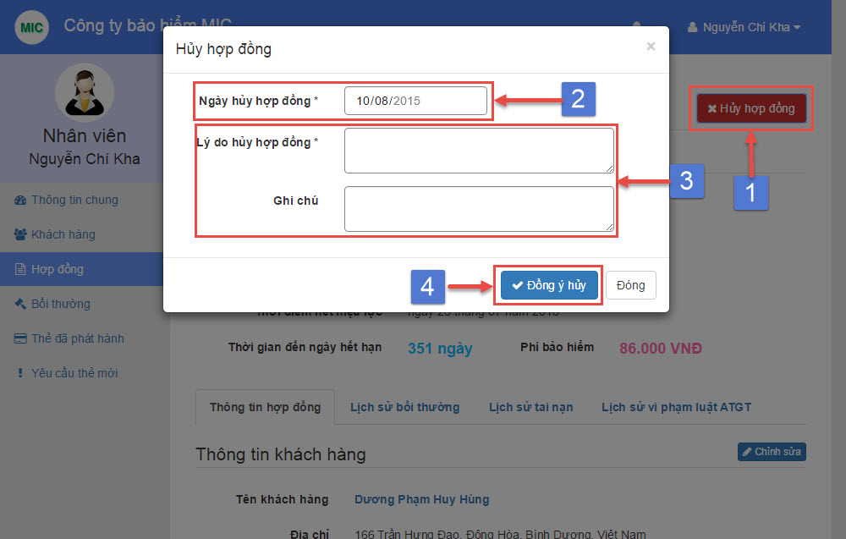

|  |  |
| --- | --- |
| Step | Description |
| 1 | Click “Hủy hợp đồng” button |
| 2 | Choose “Ngày hủy hợp đồng” the contract cancel date (required) |
| 3 | Fill “Lý do hủy hợp đồng” the contract cancel reason (required)  Fill “Ghi chú” the contract cancel note (optional) |
| 4 | Click “Đồng ý hủy” button |

##### Staff manage compensation

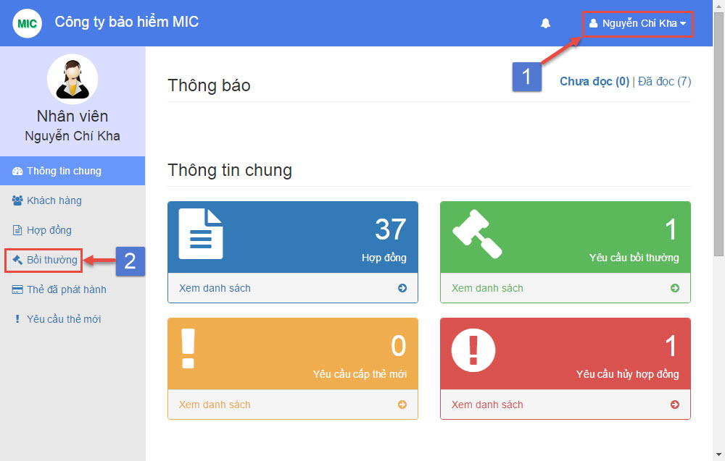

|  |  |
| --- | --- |
| Step | Description |
| 1 | Login with “Staff” role |
| 2 | Select menu “Bồi thường” from navigation bar |

##### Staff create new compensation

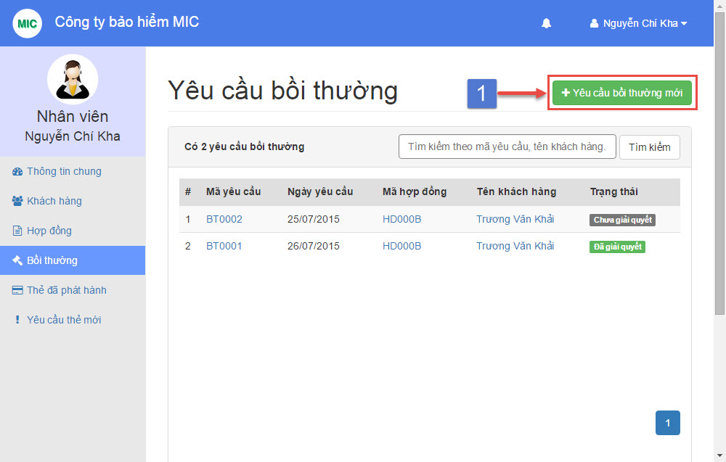

|  |  |
| --- | --- |
| Step | Description |
| 1 | Click on button “Yêu cầu bồi thường mới” |

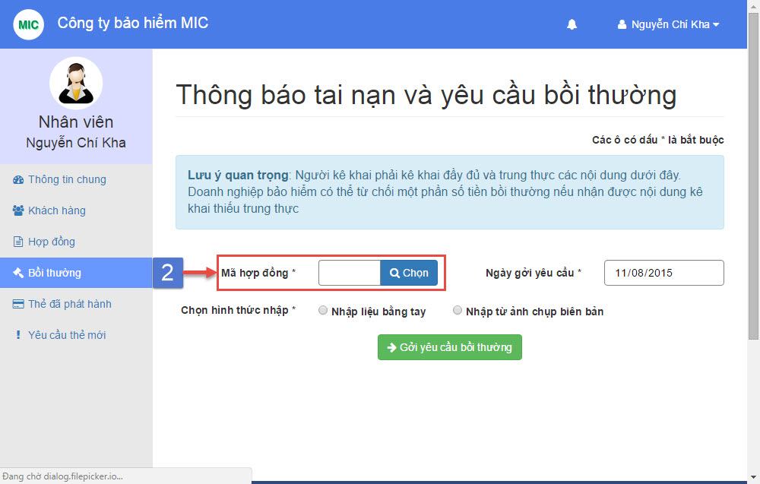

|  |  |
| --- | --- |
| Step | Description |
| 2 | Click “Chọn” button |

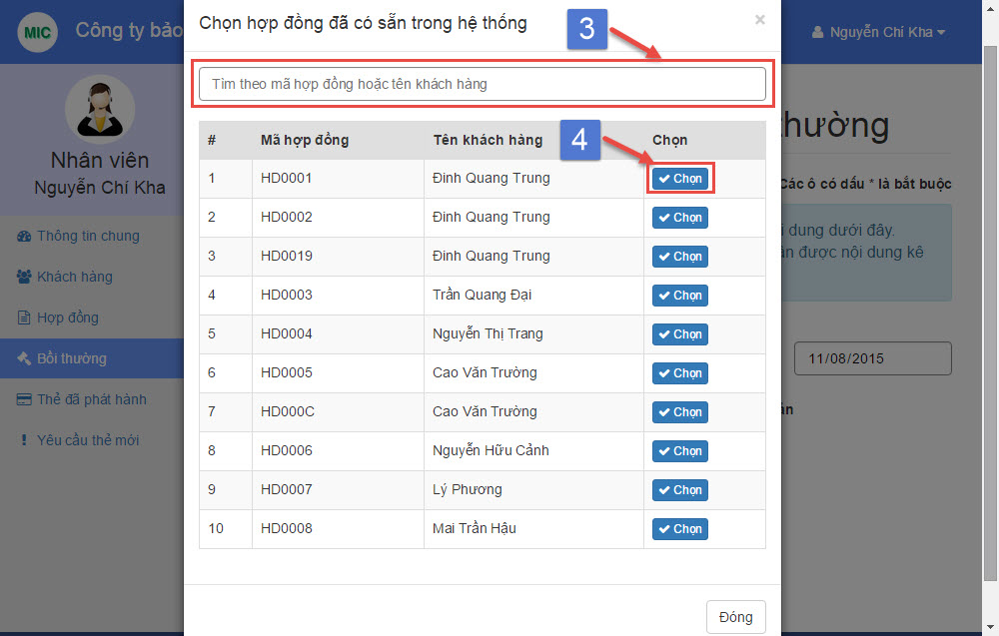

|  |  |
| --- | --- |
| Step | Description |
| 3 | Search contract by contract code or customer name |
| 4 | Click “Chọn” button |

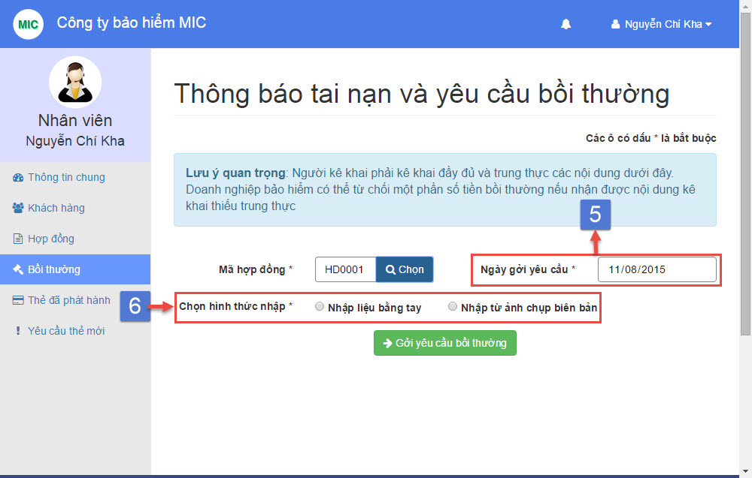

|  |  |
| --- | --- |
| Step | Description |
| 5 | Choose “Ngày gởi yêu cầu” the compensation created date (required) |
| 6 | Select “Chọn hình thức nhập” from two option (required) |

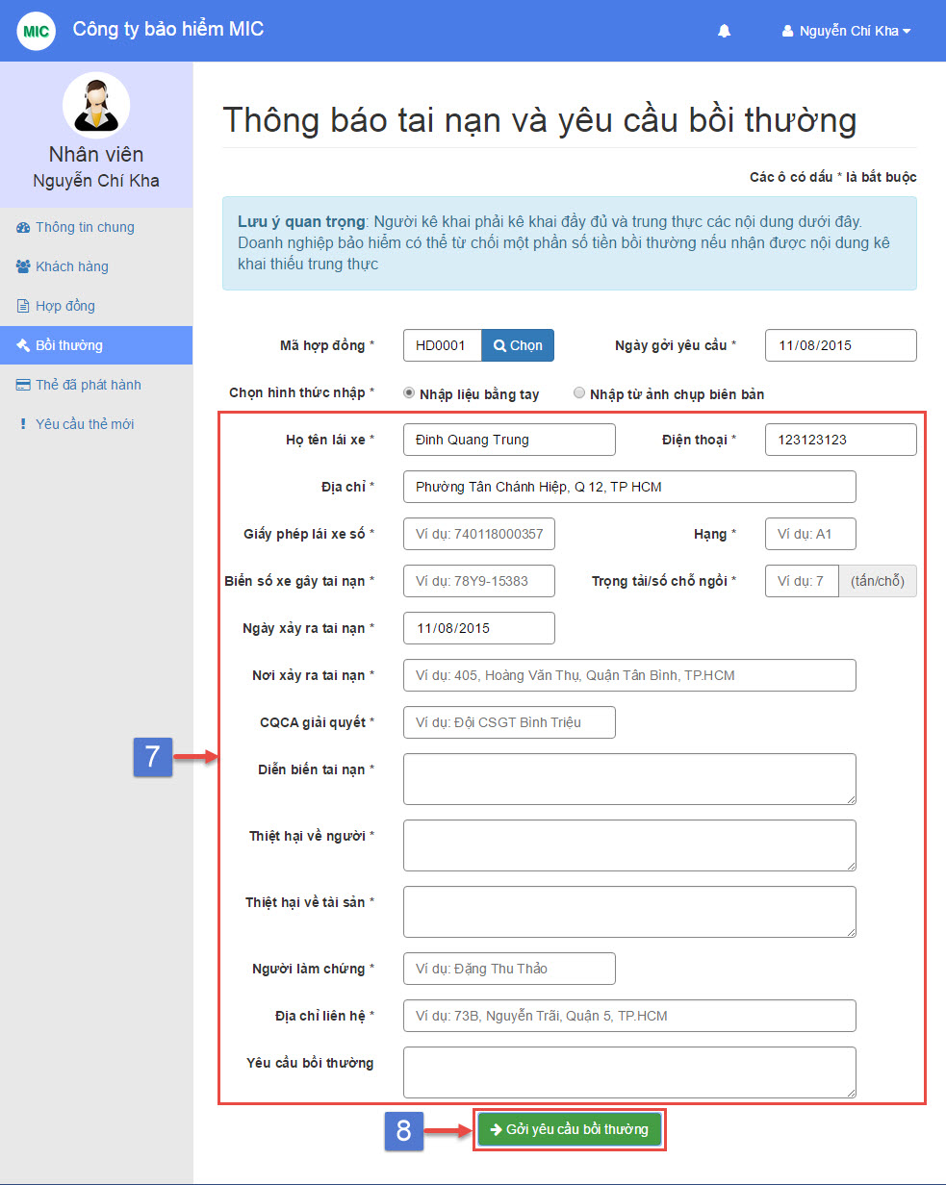

|  |  |
| --- | --- |
| Step | Description |
| 7 | Fill driver name, phone, address, license number, license type, vehicle plate, seat capacity, accident date, accident place, control deparment, description, human damage, asset damage, observer name, observer address (required)  Fill compensation request note (optional) |
| 8 | Click “Gởi yêu cầu bồi thường” button |

##### Staff view compensation detail

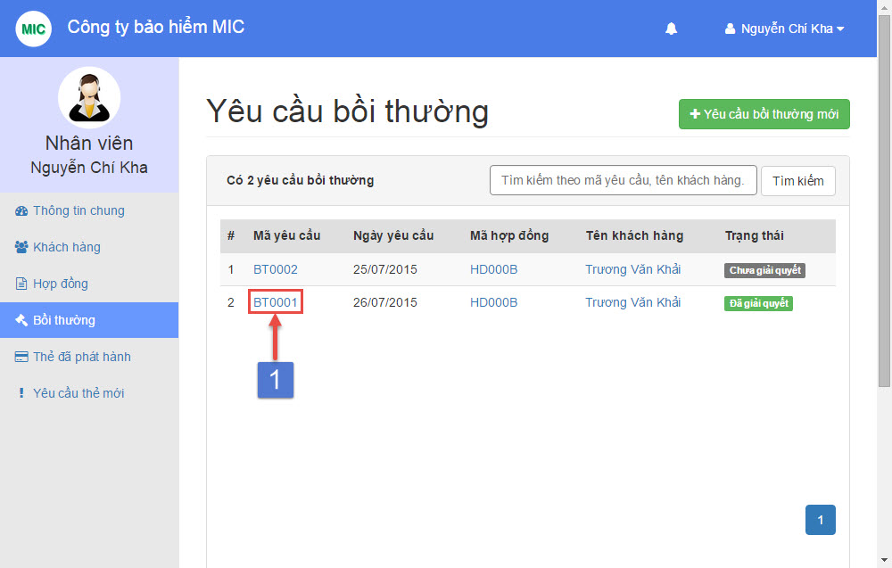

|  |  |
| --- | --- |
| Step | Description |
| 1 | Click on view compensation detail link |

##### Staff compensation cancel request

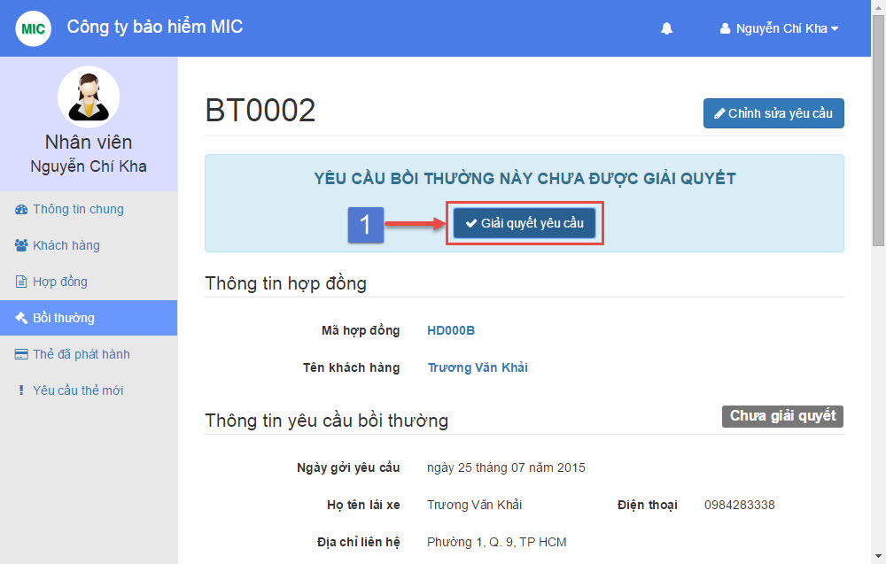

|  |  |
| --- | --- |
| Step | Description |
| 1 | Click “Giải quyết yêu cầu” button |

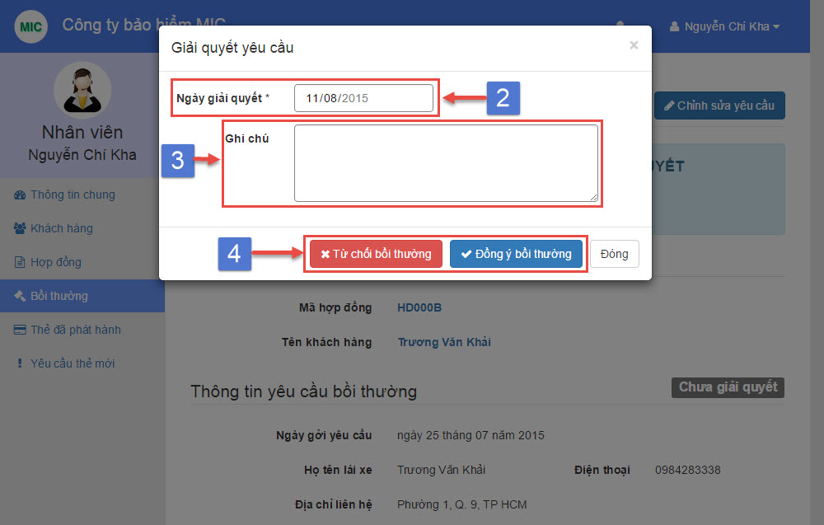

|  |  |
| --- | --- |
| Step | Description |
| 2 | Choose “Ngày giải quyết” the compensation resolved date (required) |
| 3 | Input “Ghi chú” the compensation resolve note (optional) |
| 4 | Select one from two option by click “Từ chối bồi thường” or “Đồng ý bồi thường” button |